Worksheet No. – 01

Aim/Overview of the practical: i) Implementation of Python Basic Libraries such as

a. Math

b. NumPy

c. Matplotlib

d. Seaborn

e. SciPy
Objective: To understand, explore, and apply fundamental Python libraries for numerical computing, mathematical operations, scientific computations, and data visualization to analyze and interpret datasets effectively.
Procedure/Algorithm/Code

a. Math
import math
num= 25
print("Sqaure Root:", math.sqrt(num))
print("Factorial:", math.factorial(5))
print("Pi:", math.pi)
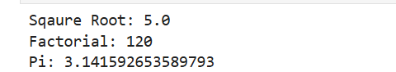

b. NumPy

import numpy as np

arr = np.array([10,20,60,70,50])

print("Array:", arr)

print("Array Addition:", arr+20)

print("Array Subtraction:", arr-15)

print("Array Multiplication", arr*20)

print("Array Division", arr/5)
Sukhleen Kaur (25MCA20031)
25MCA-6 (B)

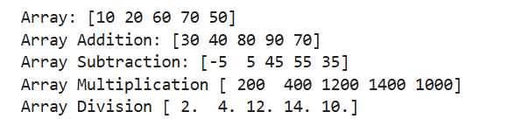

c. Matplotlib

import matplotlib.pyplot as plt

a = [2,4,6,8,10]

b = [3,4,7,2,8]

plt.plot(a,b)

plt.title("Line graph")

plt.xlabel("X-Axis")

plt.ylabel("Y-Axis")

plt.show()

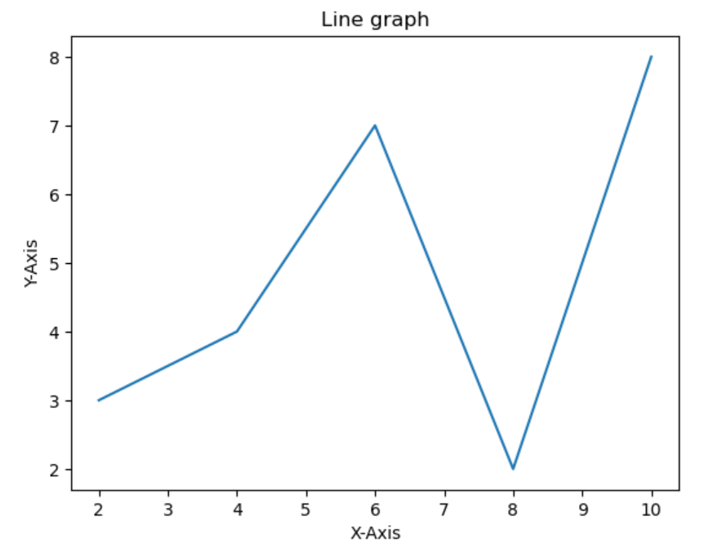

d. Seaborn

import seaborn as sns

import matplotlib.pyplot as plt

subjects = ["Math", "Science", "English", "Computer"]

marks = [85, 90, 78, 95]

sns.barplot(x=subjects, y=marks)

plt.title("Bar Plot")
Sukhleen Kaur (25MCA20031)
25MCA-6 (B)

plt.show()

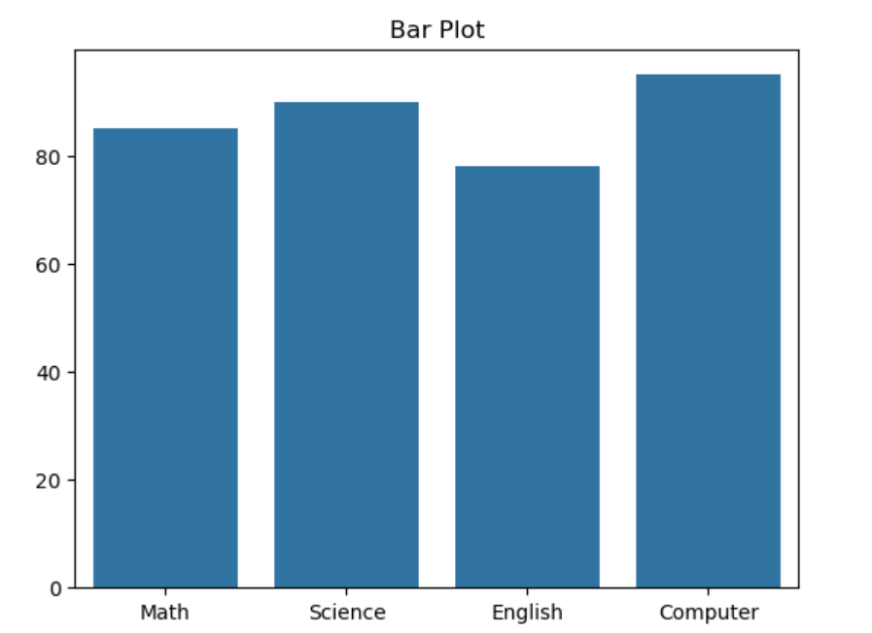

e. SciPy

from scipy import constants

print("Value of Pi:", constants.pi)

print("Speed of Light (m/s):", constants.c)

print("Gravitational Constant:", constants.G)

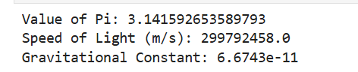

Aim/Overview of the practical: ii). Perform comprehensive data preprocessing on the Titanic dataset by handling missing values, detecting and treating outliers, encoding categorical features, applying feature scaling, and removing noise/duplicate records to improve overall data quality and prepare the dataset for machine learning tasks.
Objective: The objective of this experiment is to perform comprehensive data preprocessing on the Titanic dataset by identifying and handling missing values, detecting and treating outliers, encoding categorical variables into numerical form, applying feature scaling to normalize the data, and removing duplicate or noisy records. The preprocessing steps are carried out to improve the overall quality, consistency, and reliability of the dataset, ensuring that it is clean, well-structured, and suitable for building accurate and efficient machine learning models.

Sukhleen Kaur (25MCA20031)
25MCA-6 (B)
Procedure/Algorithm/Code
import numpy as np
import pandas as pd
from sklearn.preprocessing import OneHotEncoder, RobustScaler
data = pd.read_csv("OneDrive/Desktop/Titanic-Dataset.csv")
data = data.drop_duplicates().reset_index(drop=True)
data = data.drop(columns=["PassengerId", "Ticket"], errors="ignore")

data["Age"] = data.groupby(["Sex", "Pclass"])["Age"].transform(lambda x: x.fillna(x.median()))
data["Embarked"] = data["Embarked"].fillna(data["Embarked"].mode()[0])
data["Has_Cabin"] = data["Cabin"].notnull().astype(int)
data = data.drop(columns=["Cabin"])

data["FamilySize"] = data["SibSp"] + data["Parch"] + 1
data["IsAlone"] = (data["FamilySize"] == 1).astype(int)
data["Title"] = data["Name"].str.extract(r" ([A-Za-z]+)\.", expand=False)
data["Title"] = data["Title"].replace(
[
"Lady",
"Countess",
"Capt",
"Col",
"Don",
"Dr",
"Major",
"Rev",
"Sir",
"Jonkheer",
"Dona",
],
"Rare",
)
data["Title"] = data["Title"].replace(
{"Mlle": "Miss", "Ms": "Miss", "Mme": "Mrs"}
)
Sukhleen Kaur (25MCA20031)
25MCA-6 (B)
data = data.drop(columns=["Name"])
data["Fare_Log"] = np.log1p(data["Fare"])
def cap_outliers_iqr(df, column):
Q1 = df[column].quantile(0.25)
Q3 = df[column].quantile(0.75)
IQR = Q3 - Q1
lower_bound = Q1 - 1.5 * IQR
upper_bound = Q3 + 1.5 * IQR
df[column] = np.clip(df[column], lower_bound, upper_bound)
return df

data = cap_outliers_iqr(data, "Fare_Log")
data = data.drop(columns=["Fare"])
data["Sex"] = data["Sex"].map({"male": 0, "female": 1})
data = pd.get_dummies(
data, columns=["Embarked", "Title"], drop_first=True, dtype=int
)
scaler = RobustScaler()
num_cols = ["Age", "Fare_Log", "FamilySize"]
data[num_cols] = scaler.fit_transform(data[num_cols])
print("Missing values per column:\n", data.isnull().sum())
data.head()
OUTPUT
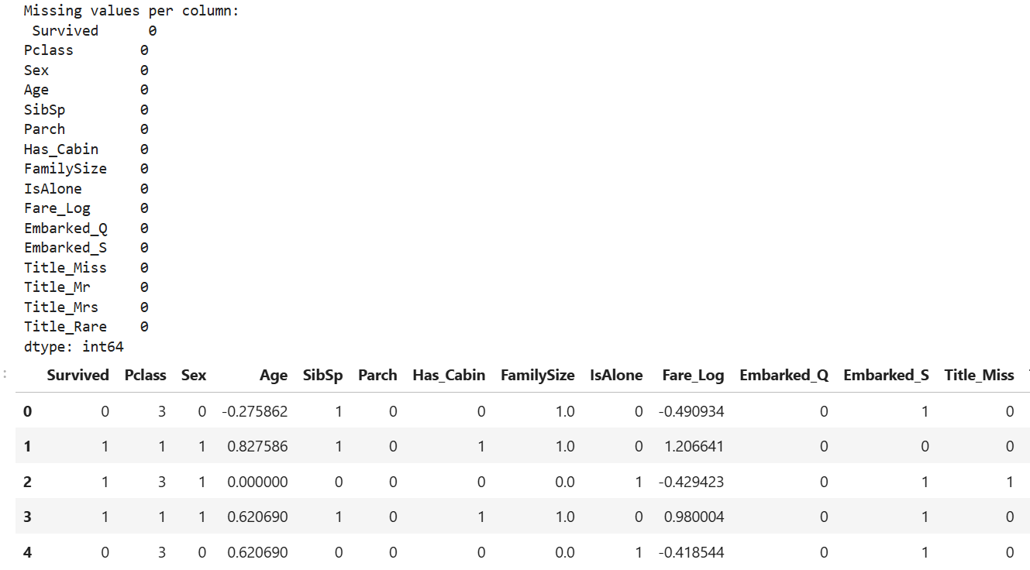
Sukhleen Kaur (25MCA20031)
25MCA-6 (B)
Learning outcomes (What I have learnt):
- Understand and implement Python libraries (Math, NumPy, Matplotlib, Seaborn, and SciPy).
- Perform numerical computation, data analysis, and data visualization using Python.
- Handle missing values, outliers, and duplicate records in the Titanic dataset.

